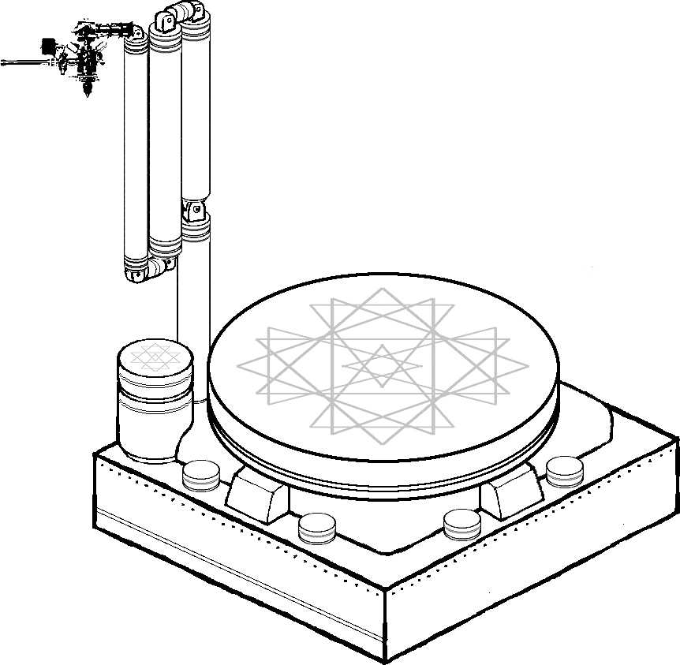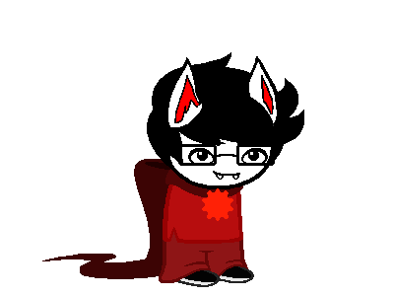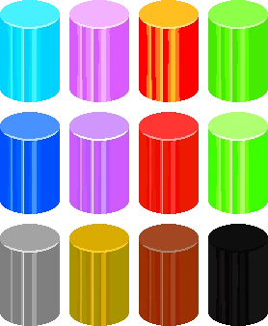



>>Outfit Combinations:

Short-Sleeve && Generic = Heir, Seer, Thief, Mage, Scribe

Layered-Sleeves && Knight = Knight

Long-Sleeve && Generic = Maid, Witch

Short-Sleeve && Prince = Prince

Layered-Sleeves && Bard = Page, Bard

Sleeveless && Sylph = Sylph

Sleeveless && Rogue = Rogue

Grace-Shirt && Grace = Grace

Sage-Shirt && Generic = Sage

Muscle-Joke && Anything = jR